D.P.T. Class of 2019 Share Their Good Works at Community Service Presentations
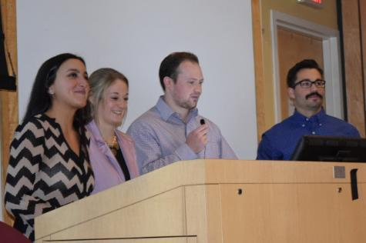
Community service projects carried out by Doctor of Physical Therapy (D.P.T.) students in the School of Health Sciences are a win-win. Students learn important lessons in planning, executing and assessing an activity that addresses a local or underserved community need and a host of beneficiaries gain from their hard work, skills and knowledge. This year, the D.P.T. Class of 2019 shared their community service projects and outcomes with the College community, on November 30 in Nevins Auditorium. They also gave first-hand and sage advice to members of the D.P.T. Class of 2020 who will build upon the success of the projects and expand their scope. Innovations to this year’s projects included creating a video of the Race for Rehab course that was available for participants to view prior to the race and developing a breathing and relaxation technique brochure and assembling toiletry care packages for My Sister’s Place, an organization that provides shelter and services to battered women and their children and victims of human trafficking. View the D.P.T. Community Service Project Presentations photo gallery.
D.P.T. Class of 2019 Community Service Projects
19th Annual Race for Rehab for Achilles International
Moonki Baik, Kenesha Brown, Victoria Colon, Elizabeth Czigler, Samantha Fanelli, Matthew Fedorchak, Paige Forsthoff, Ben Hylka, Jessica Otchy, Eric Pec, Emma Shollar, Michael Taurone, Danielle Van Kluyve and Tyler Van Benschoten
Faculty Advisors: Janet Dolot, P.T., D.P.T., Dr.P.H. ’14, assistant professor of physical therapy, and Anthony M. Sozzo, M.S.Ed., M.A., associate dean for student affairs and director of student financial planning and student activities
Health and Wellness: Health Awareness Through Ergonomic and Blood Pressure Screenings
Maureen Anders, Shene Davis, John Detienne, Claire Duffy, Olivia Fiscaletti, Jasmin Folch, Shayna Ginsburg, Dale Hua, Christine Myers, Alison O’Connell, Steven Paulus, Rebecca Sachs, Gemma Striker and Sinjin Wightman
Faculty Advisor: Susan L. Ronan, P.T., D.P.T., P.C.S., assistant professor of physical therapy
AFYA-Global Outreach
Julianne Battista, Kristina Bilanova, Rebecca Colombie, Adrian Flanigan, Victor Gondar, Janis Konkle, Jennifer Lee, Christina O’Connor, Samuel O’Keefe, Stephanie Savino, Adam Schayek, Evan Stein, Deanna Utter and Kelly Winans
Faculty Advisors: Catherine L. Curtis, P.T., M.A., Ed.M., Ed.D., assistant professor of physical therapy, and Gale J. Lavinder, P.T. Ed.D., assistant professor of physical therapy

